OOP Lab Practical – 1

Name: Divyam Kumar

SAPID: 500083141

Roll No: R214220434

Batch: B2

1. Downloading JDK-8

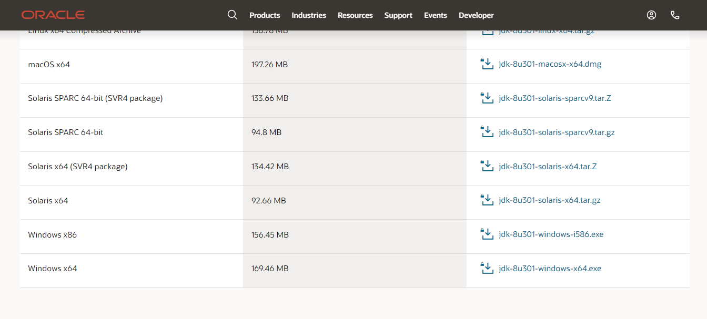

1. Installing JDK

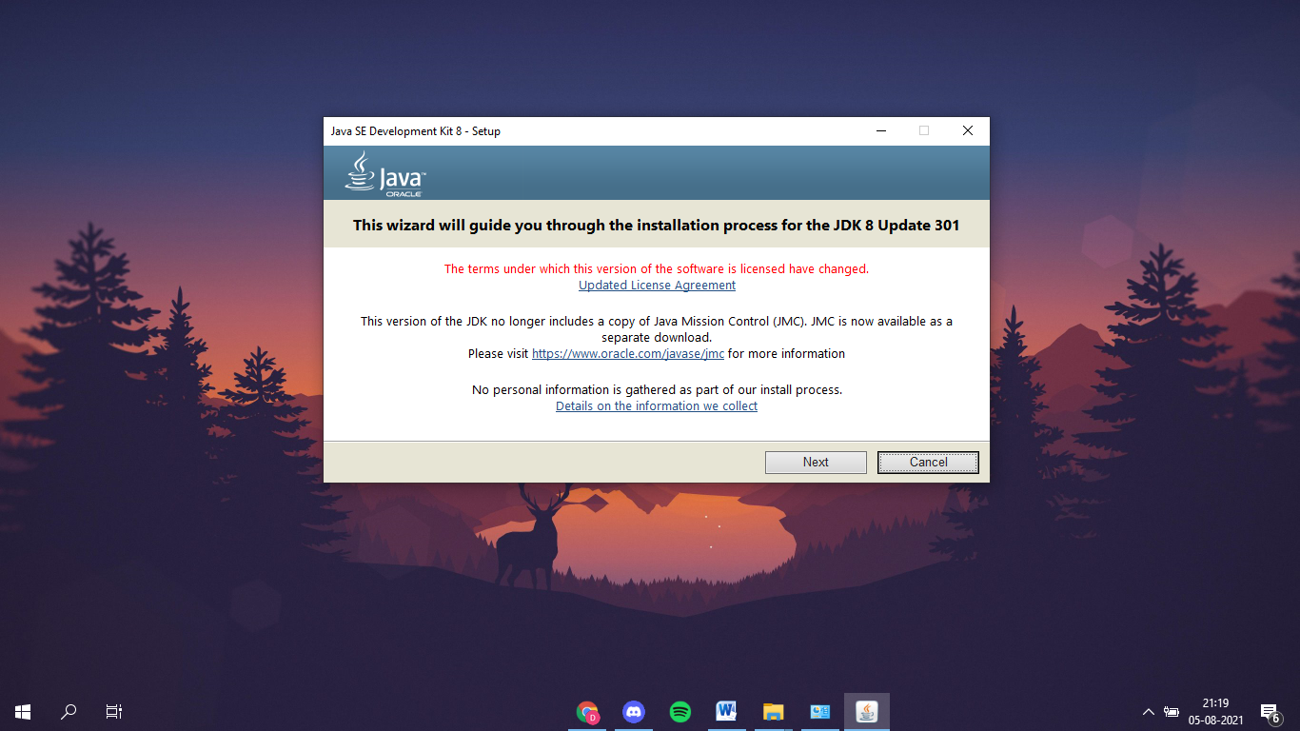

* Downloading Development Tools

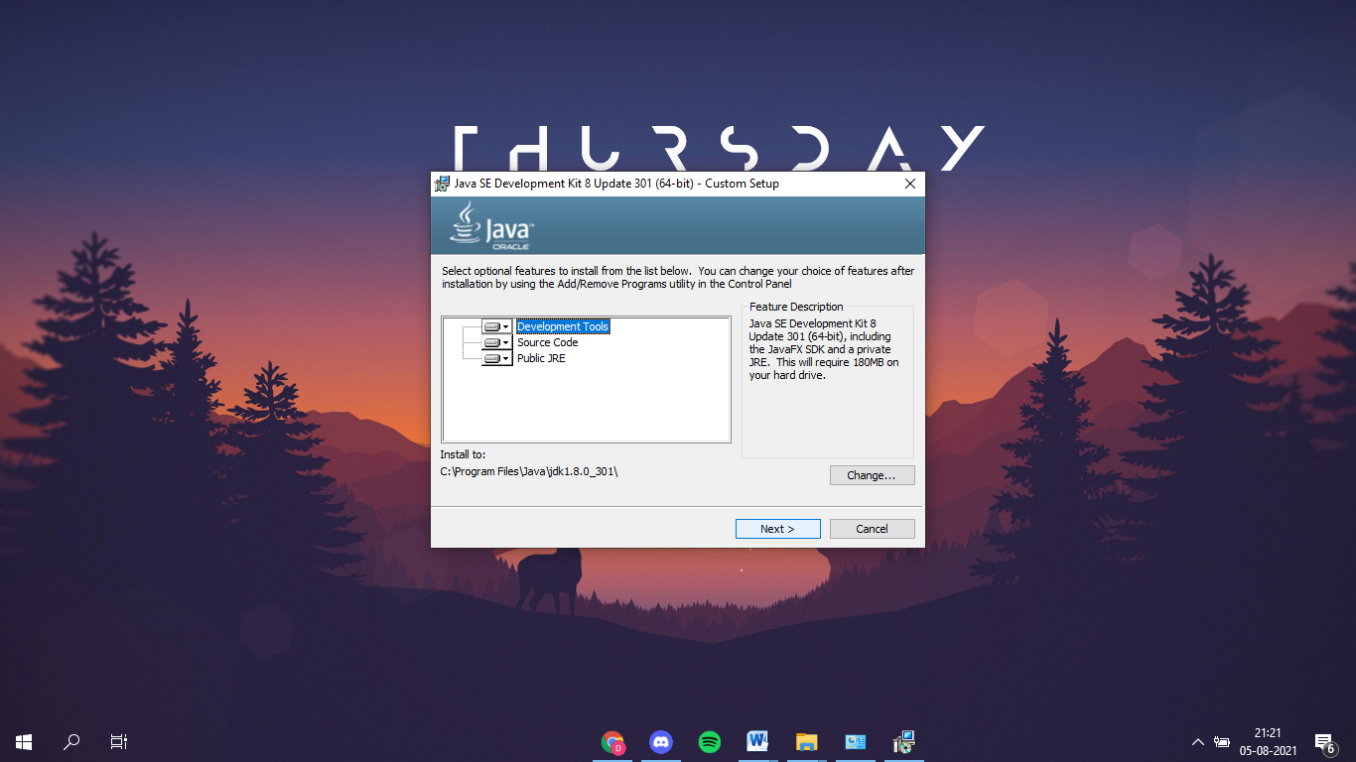

* Choosing Destination Folder

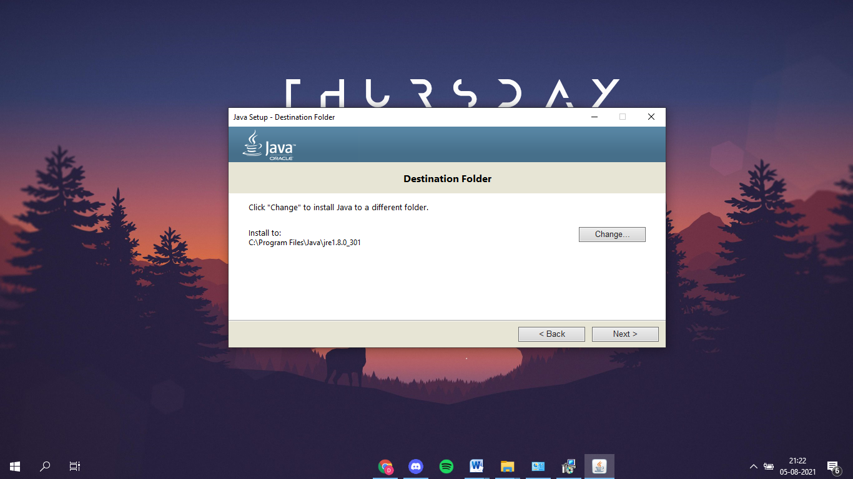

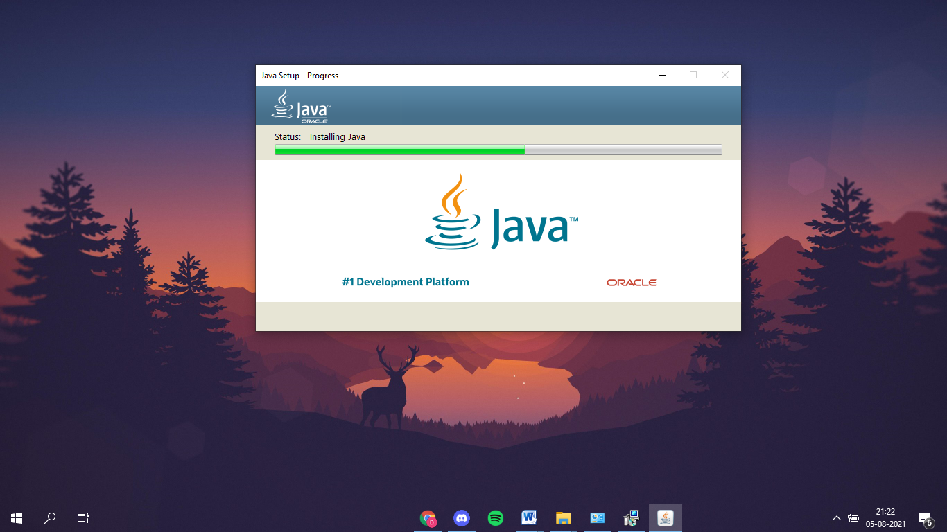

* Installation Complete

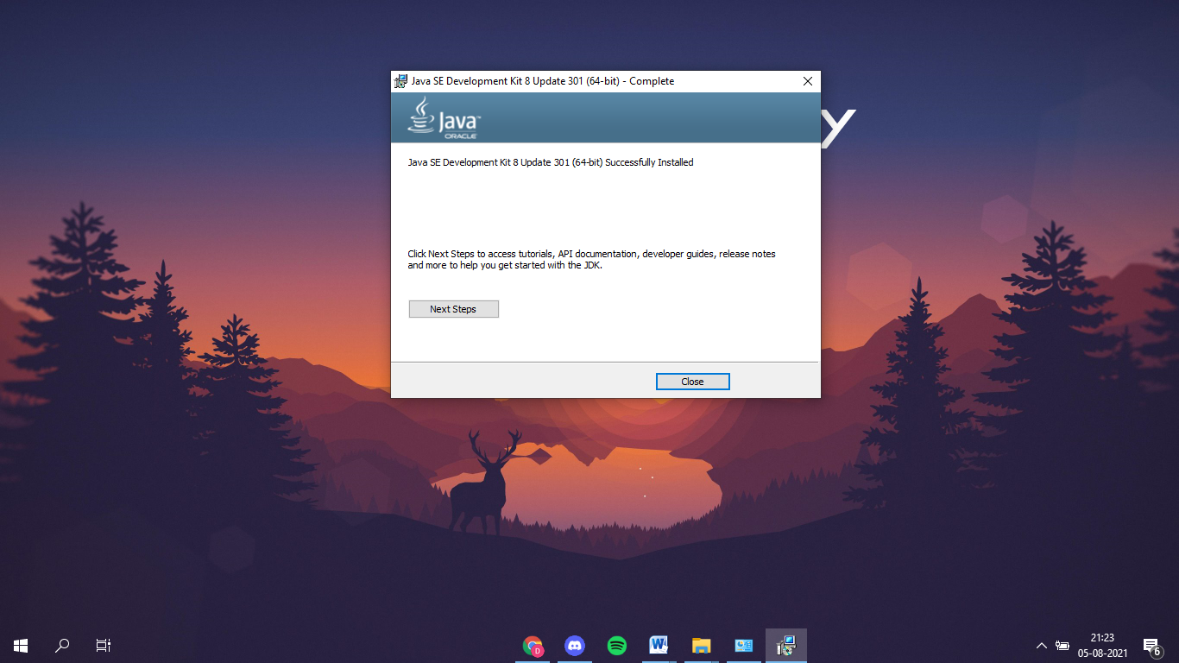

1. Setting up Path Variables

* Locating “bin” folder in C:\Program Files\Java\jdk1.8.0_301\bin

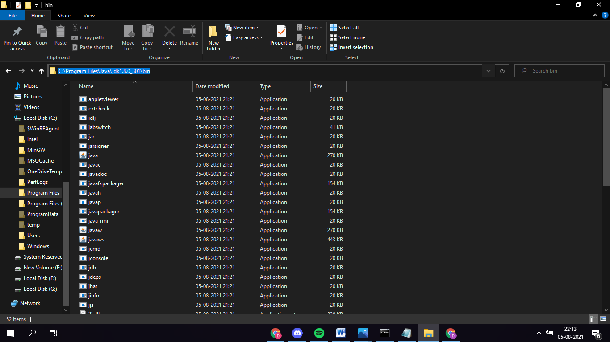

* 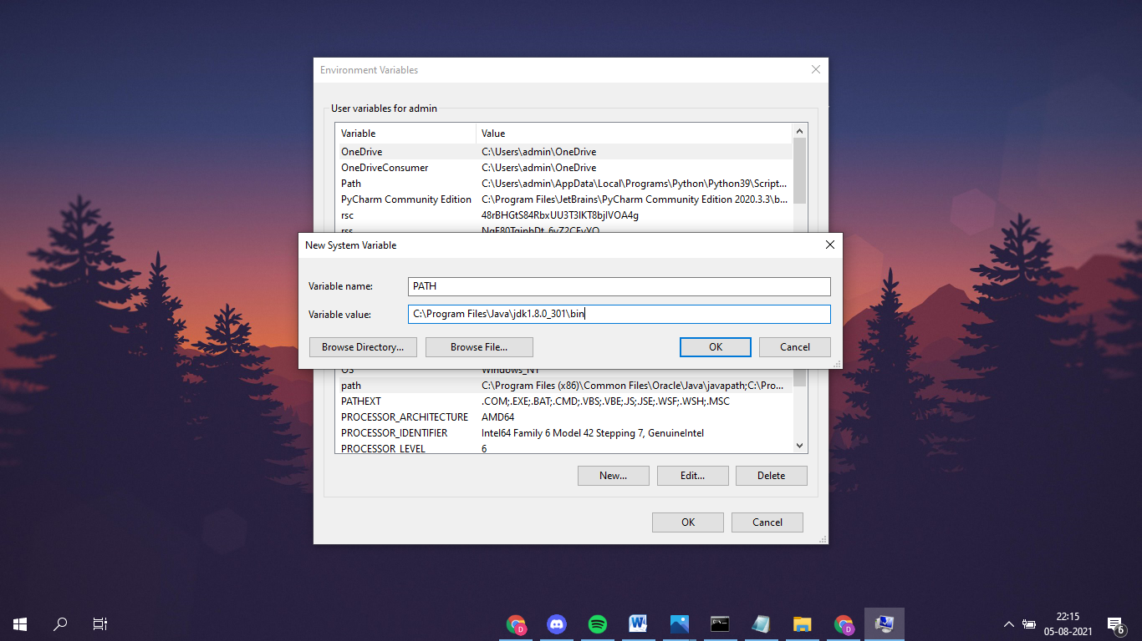Setting up Path in the Environment Variables

1. Running my First Code

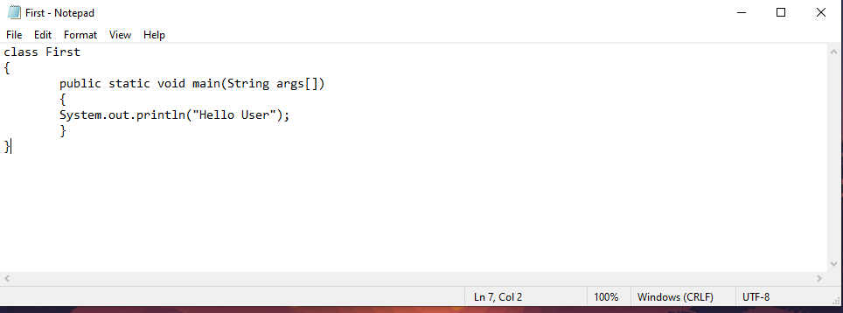

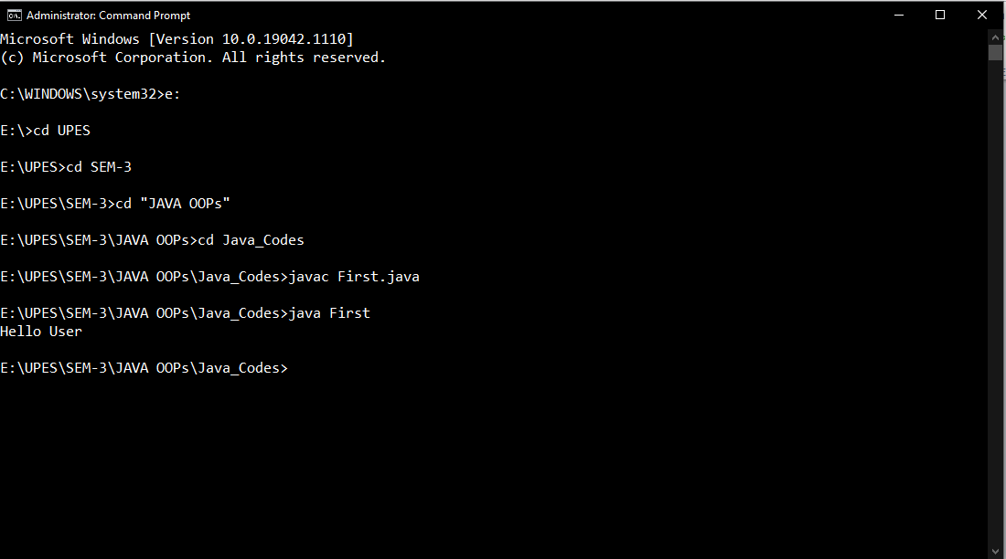

1. JAVA IDEs

An IDE is short for Integrated Development Environment.

Few of the JAVA IDEs are :-

* Eclipse: A dedicated Java IDE. The modern integrated development environment is available in both desktop and cloud editions..
* NetBeans: NetBeans is the official IDE for Java 8. The open-source IDE facilitates Java programmers to build desktop, mobile, and web applications by offering a range of potent tools and features.
* IntelliJ IDEA: It is available in 2 different editions, an Apache 2 Licensed community edition, and a proprietary commercial edition. To allow developers to dive deeper into the Java code, IntelliJ IDEA boasts cross-language refactoring and data flow analysis features.
* BlueJ: BlueJ is an (integrated development environment) IDE for Java and . Though mainly designed with educational intent, BlueJ is apt for small-scale software development. Despite being developed as a ready-to-go IDE for beginners, Java veterans widely prefer this Java IDE